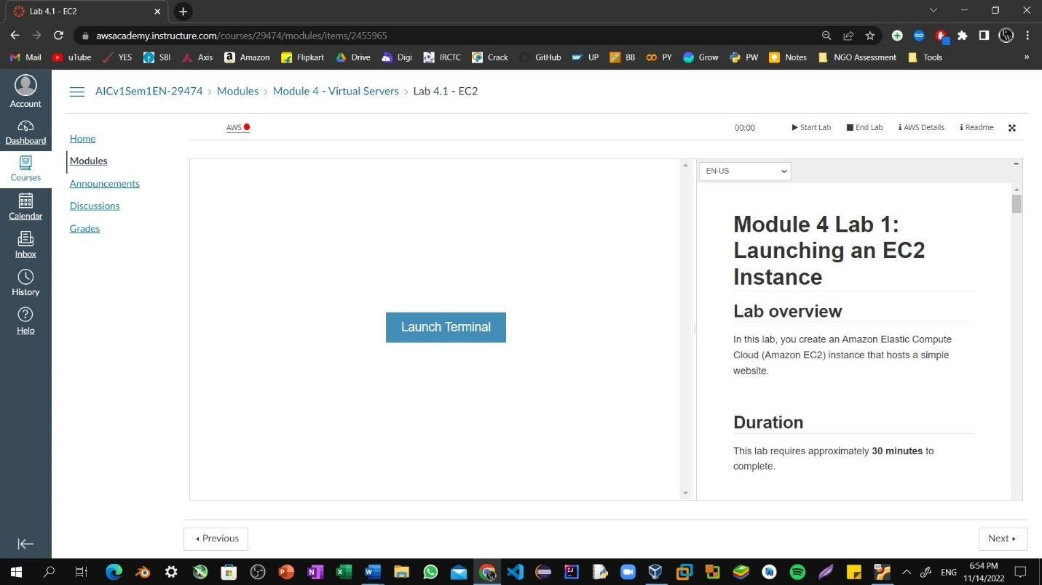Step1: To start the lab session, choose **Start Lab** in the upper-right corner of the page.

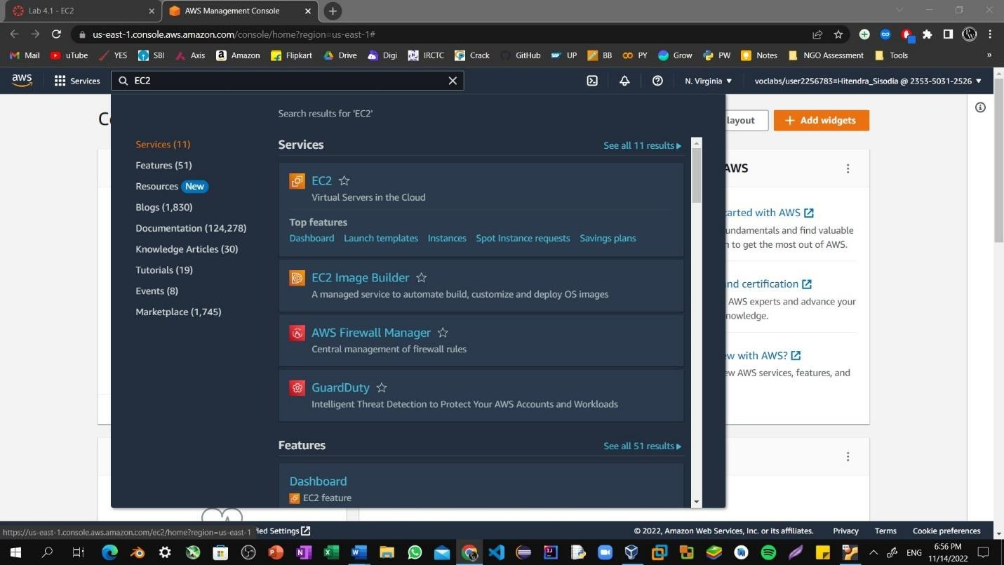Step2: Choose the **Services** menu, locate the **Compute** services, and select **EC2.**

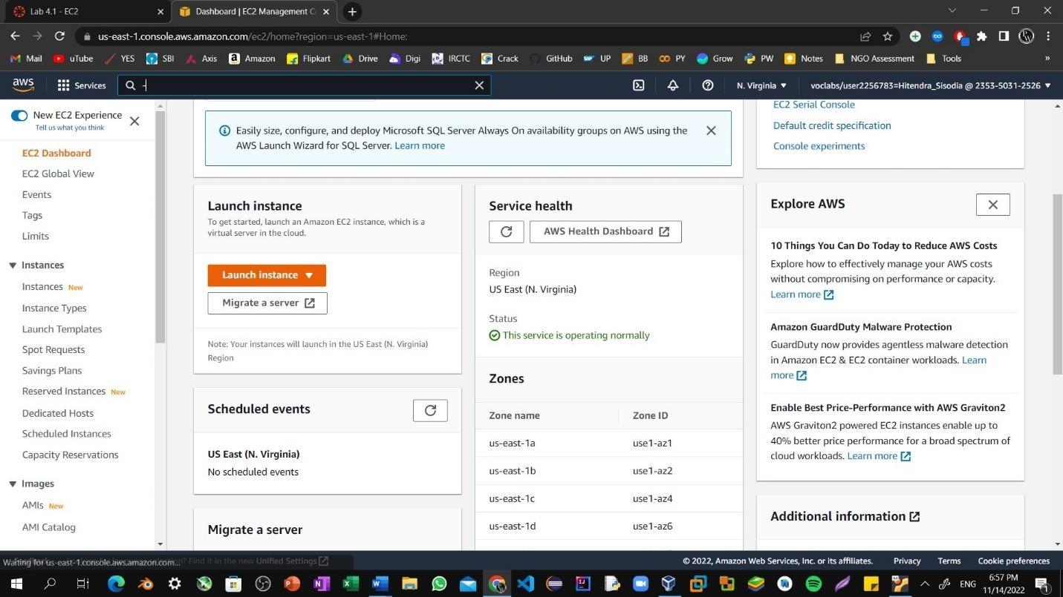Step3: Choose the **Launch instance** button in the middle of the page, and then select **Launch instance** from the dropdown menu.

Step4: Name the instance i.e, Hitendra Sisodia.

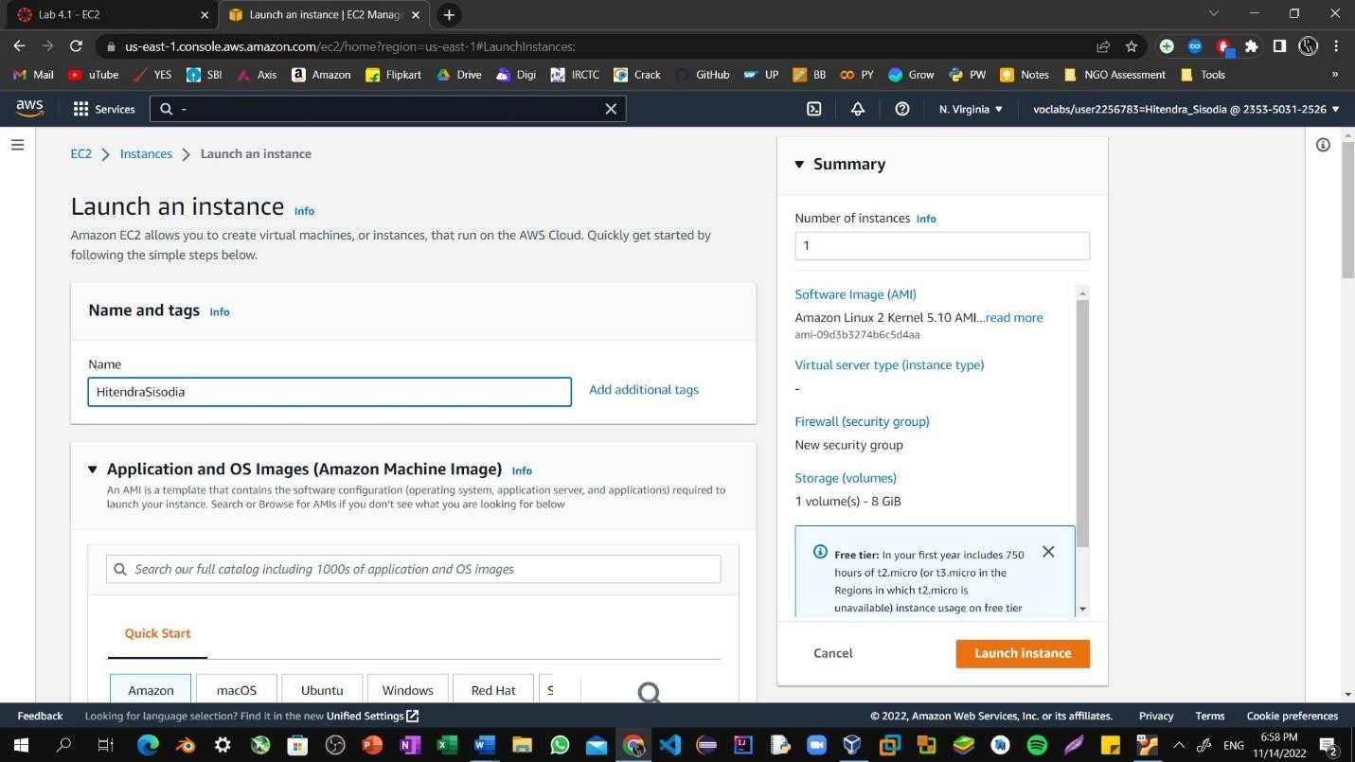

Step5: Choose an AMI from which to create the instance:

In the list of available *Quick Start* AMIs, keep the default **Amazon Linux** AMI selected. Also keep the default **Amazon Linux 2 AMI (HVM)** selected.

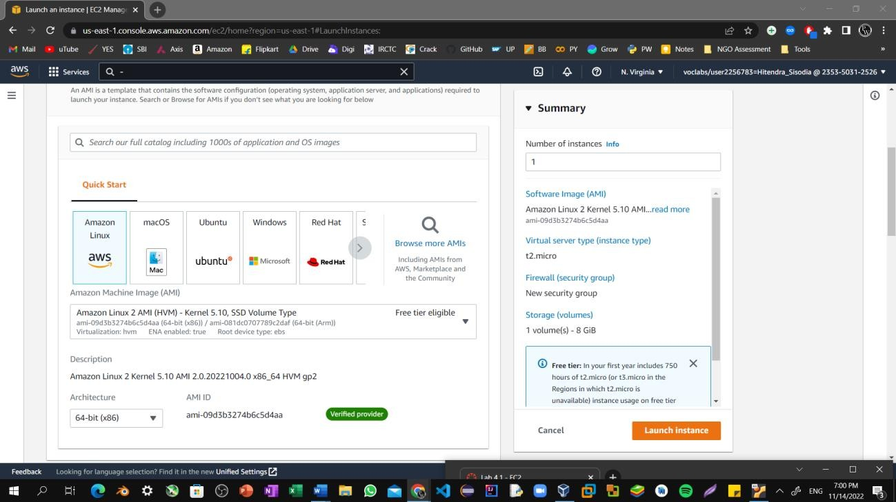

Step6: Specify an Instance type: In the *Instance type* panel, keep the default

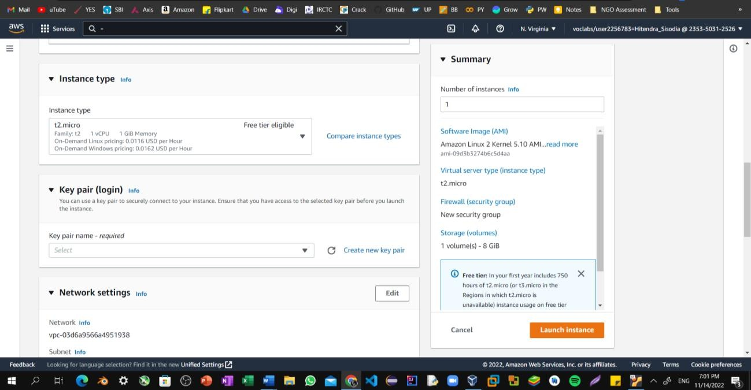**t2.micro** selected.

Step7: Select the key pair to associate with the instance. From the **Key pair name**

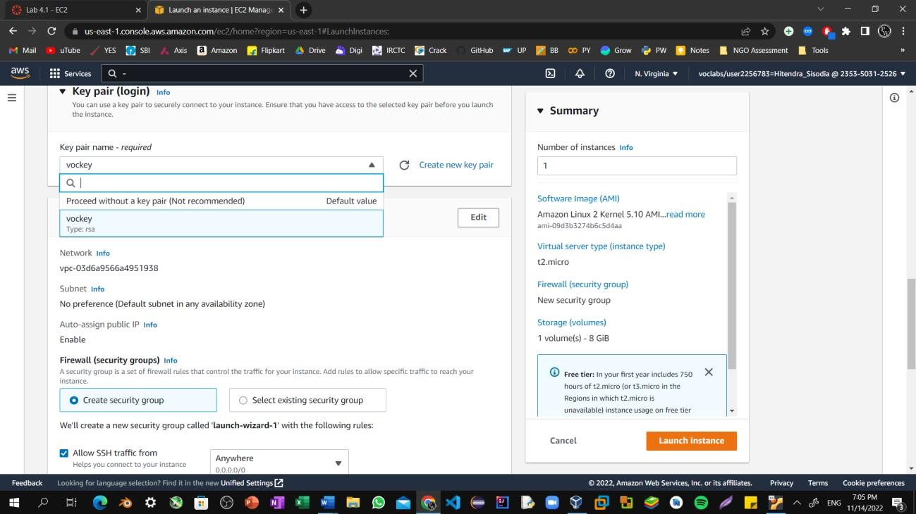menu, select **vockey**.

Step8: Next to Network settings, choose **Edit**. Keep the default *VPC* and *subnet*

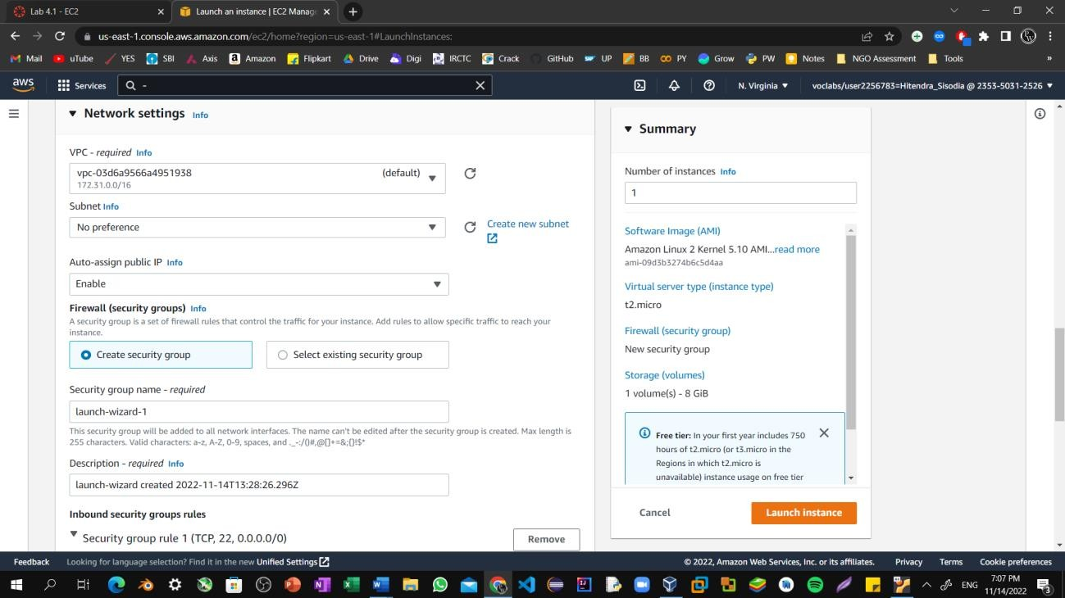settings. Also keep the **Auto-assign public IP** setting set to **Enable**.

Step9: Under *Firewall (security groups)*, keep the default **Create security group**

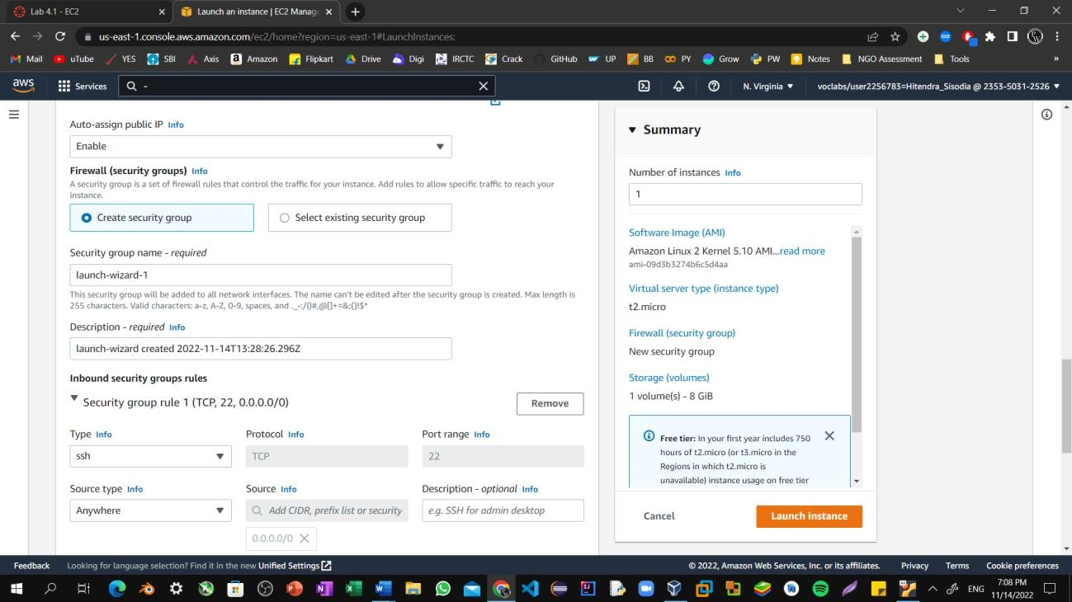option chosen.

Step10: Configure a new security group:

Keep the default selection **Create a new security group**.

**Security group name:** Clear the text and enter Web Server.

**Description:** Clear the text and enter Security group for my web server.

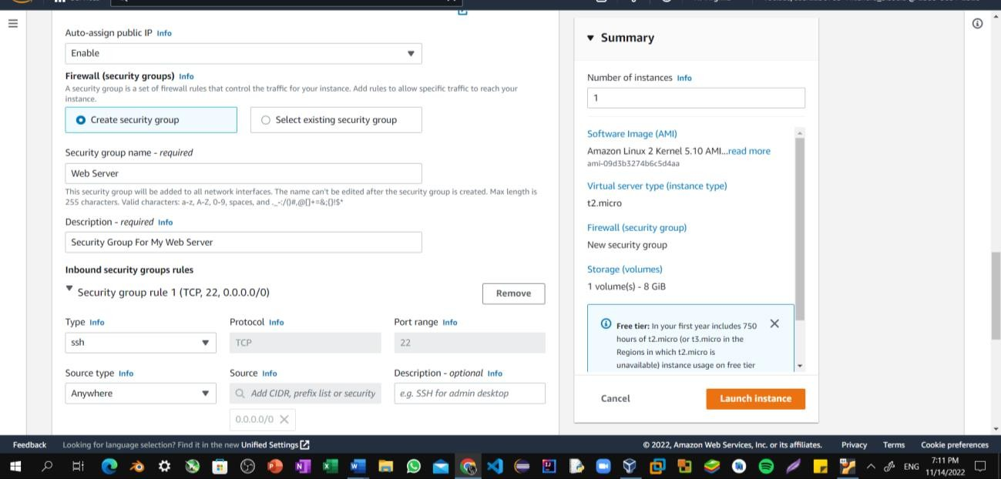

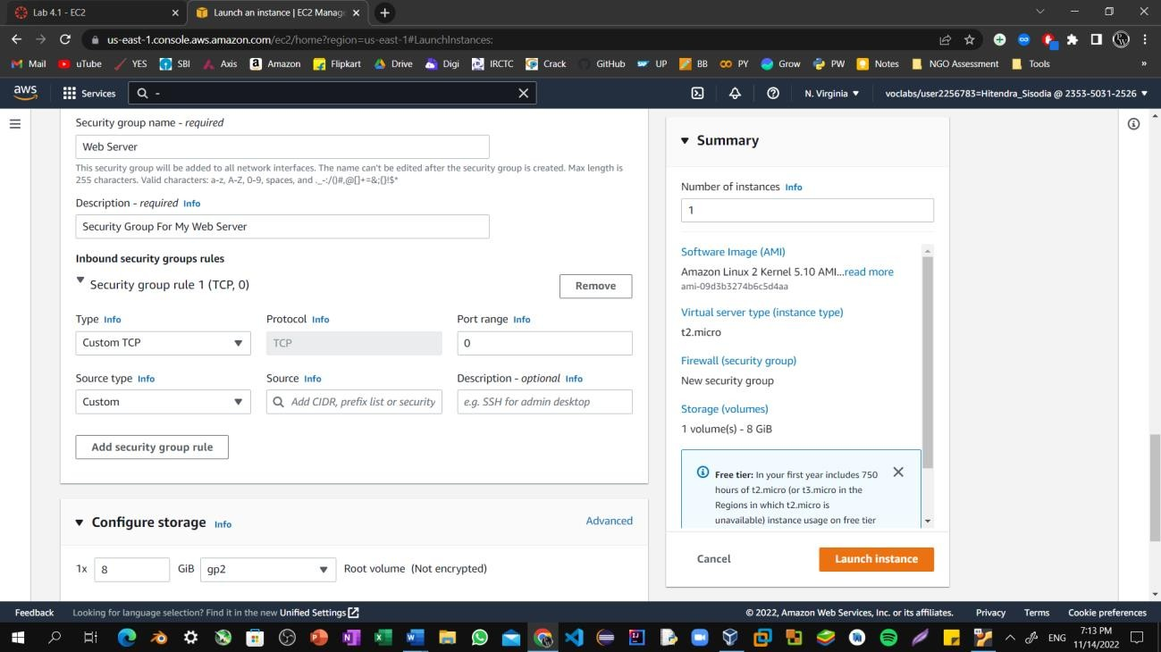 Step11: Choose **Remove** to remove the default SSH inbound rule.

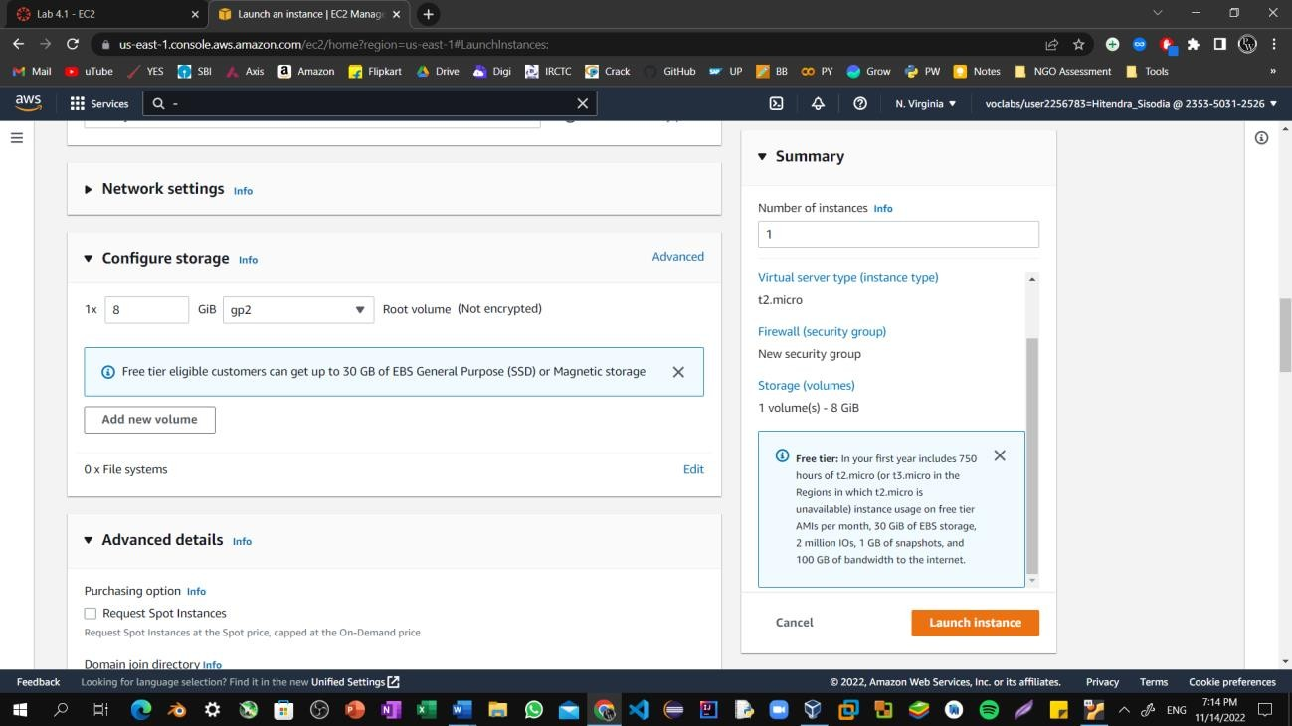Step12: In the *Configure storage* section, keep the default settings. You will launch the Amazon EC2 instance using a default Elastic Block Store (EBS) disk volume.

Step13: Configure a script to run on the instance when it launches:

* 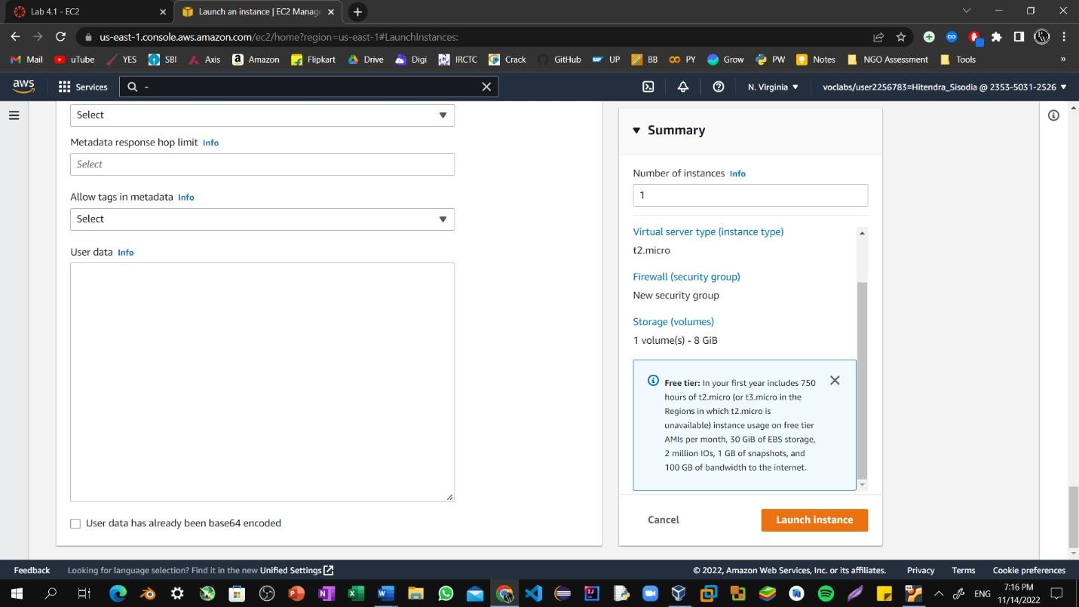Expand the **Advanced details** panel.

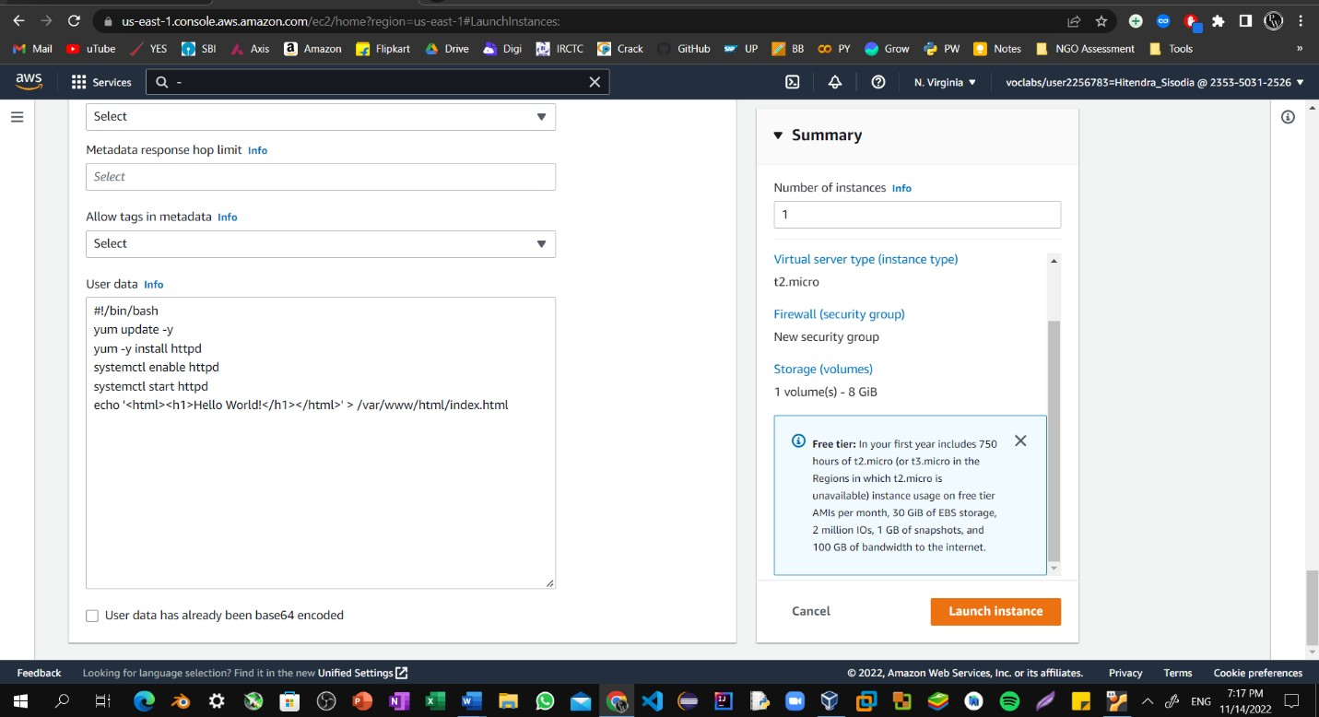Step14: Scroll to the bottom of the page and then copy and paste the code shown below into the **User data** box.

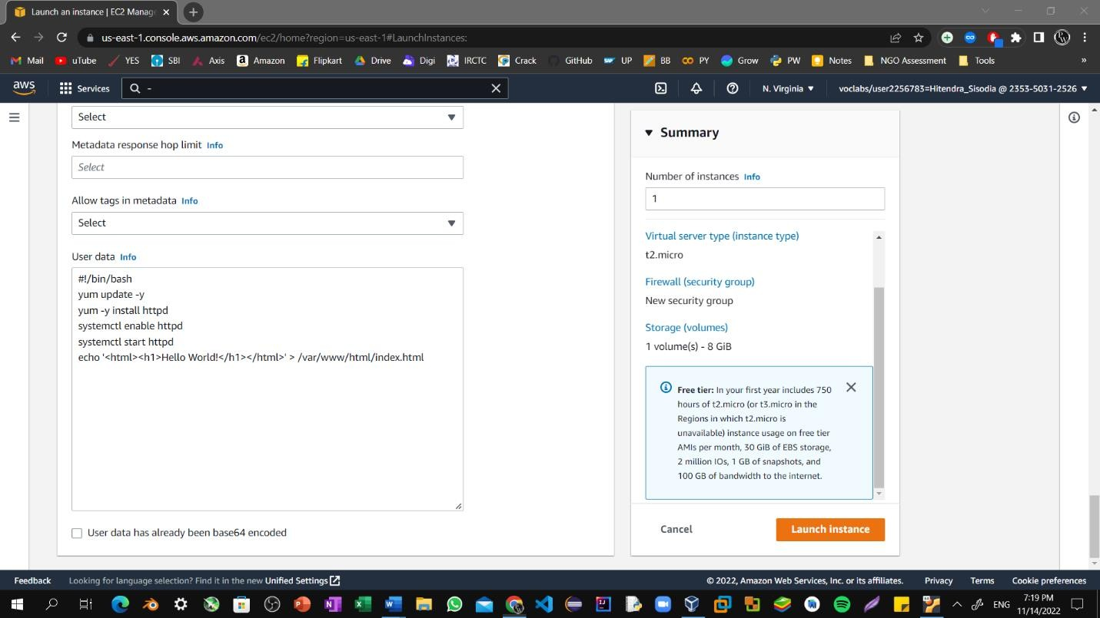Step15: At the bottom of the **Summary** panel on the right side of the screen choose Launch Instances. You will see a Success message.

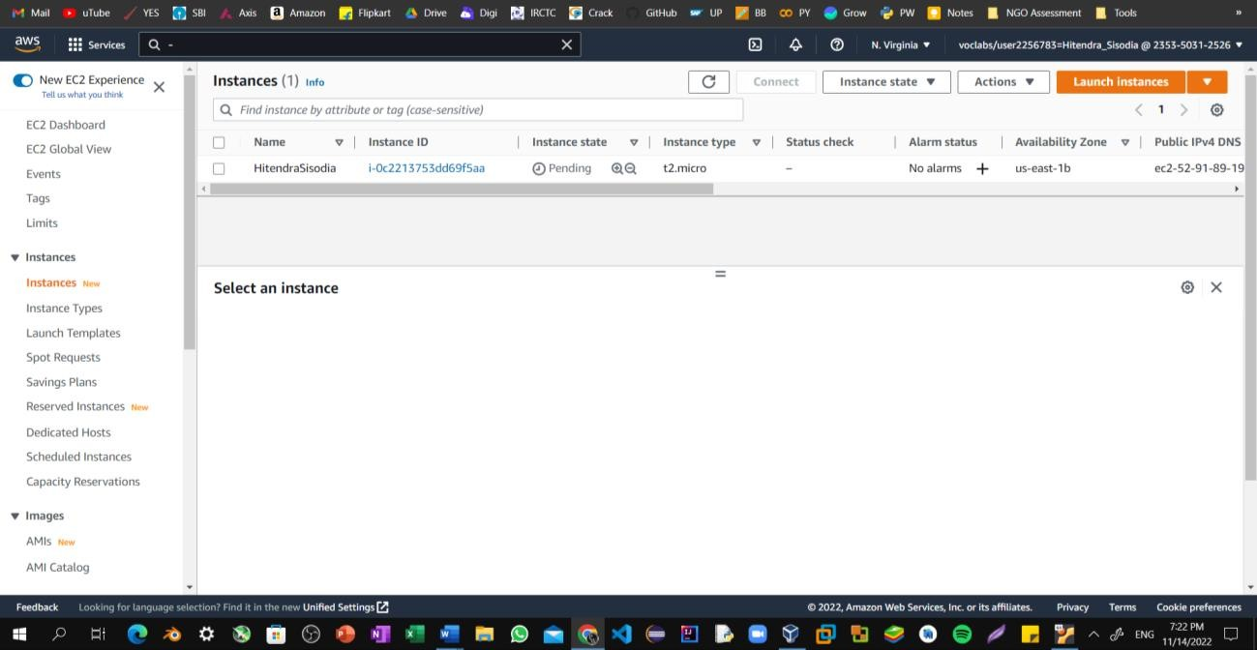Step16: The instance will first appear in the *Pending* state, which means it is being launched. The state will then change to *Running*, which indicates that the instance has started booting. It takes a few minutes for the instance to boot.

Step17: Before you continue, wait for your instance to display the following:

**Instance state:** *Running*

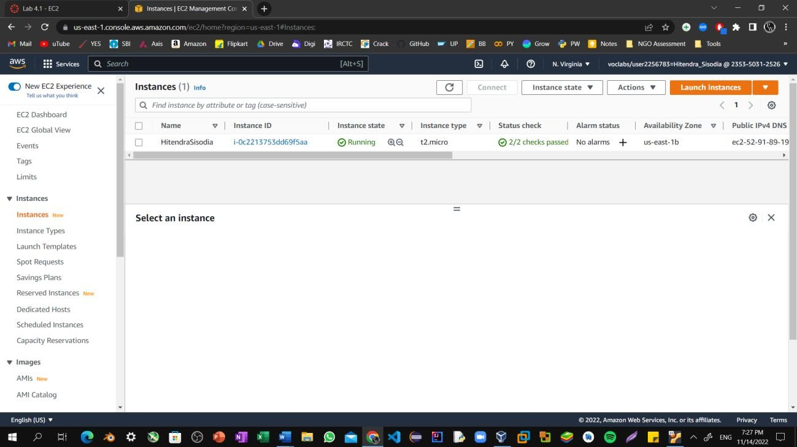**Status check:** *2/2 checks passed*

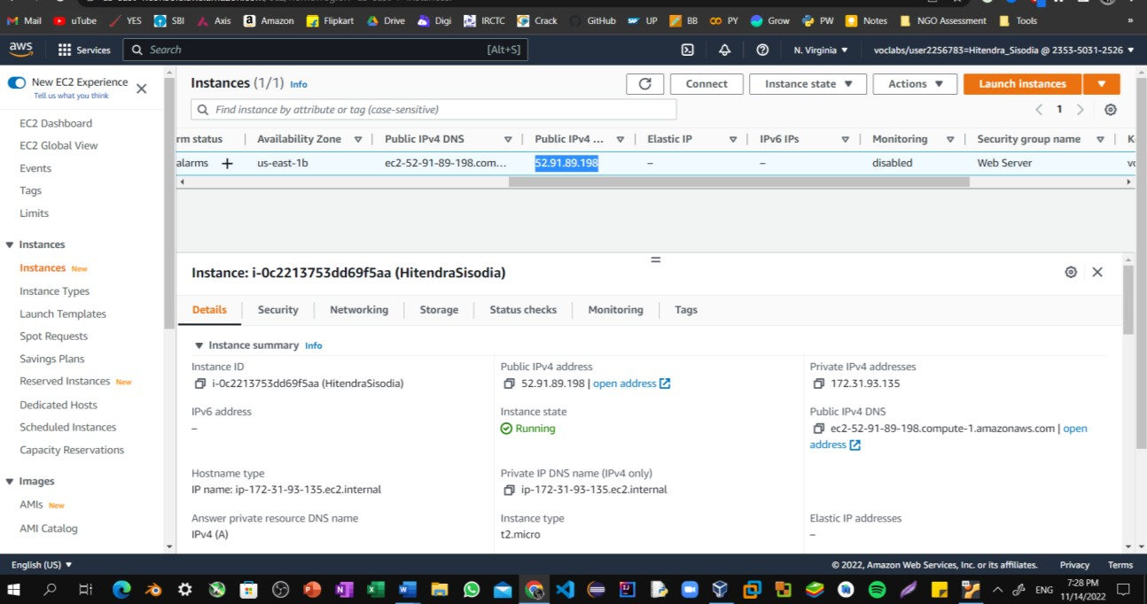Step18: From the **Details** tab, copy the **Public IPv4 address** value of your instance to your clipboard.

Step19: Open a new tab in your web browser, paste the public IP address you just copied, and press **Enter**.

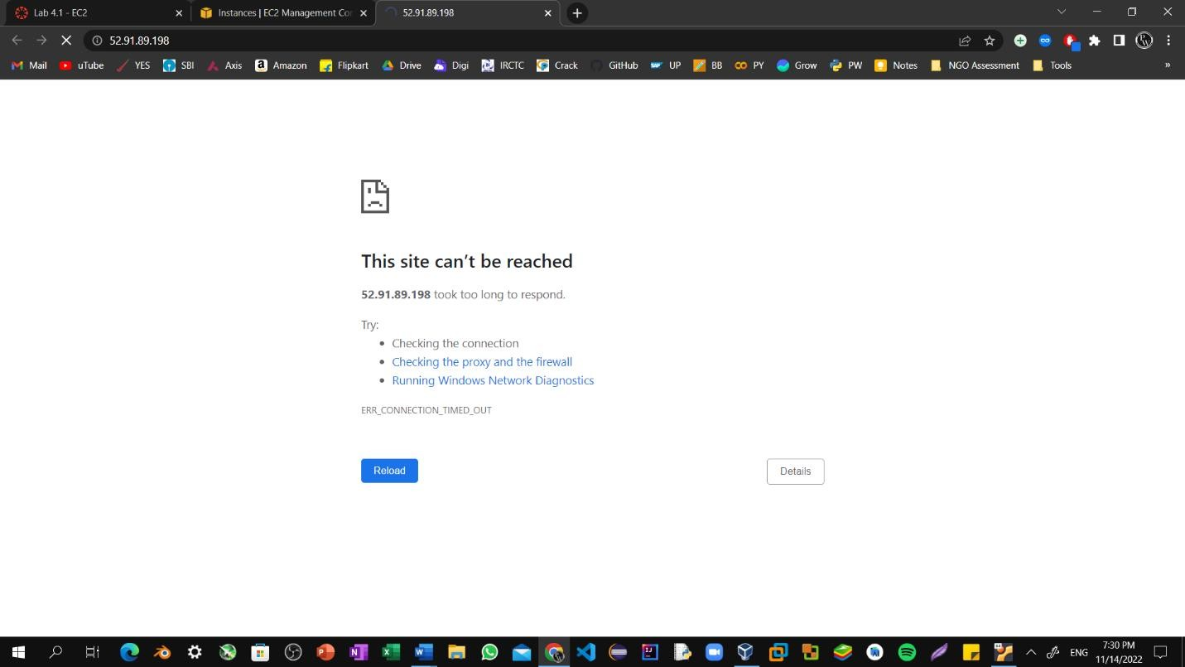The webpage does not load. You must update the security group to be able to access the page.

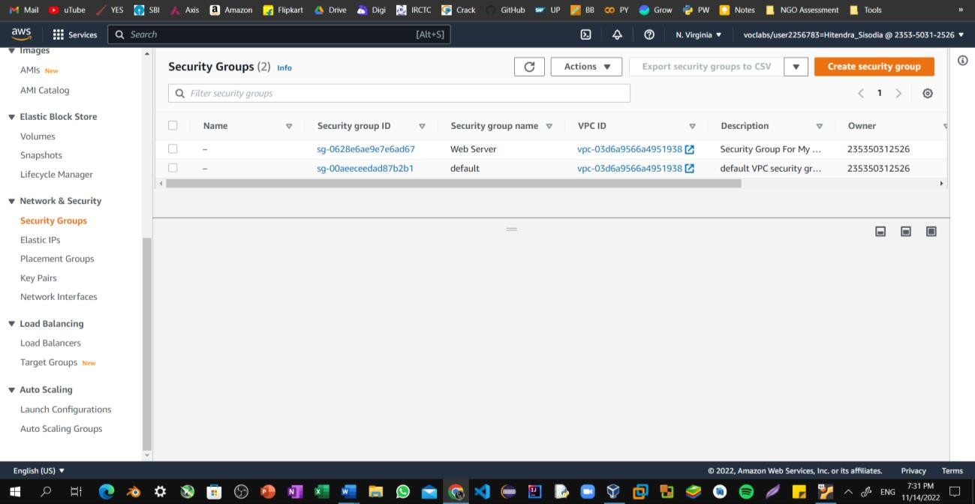Step20: Return to the **EC2 Management Console** browser tab. In the left navigation pane, under **Network & Security**, choose **Security Groups**.

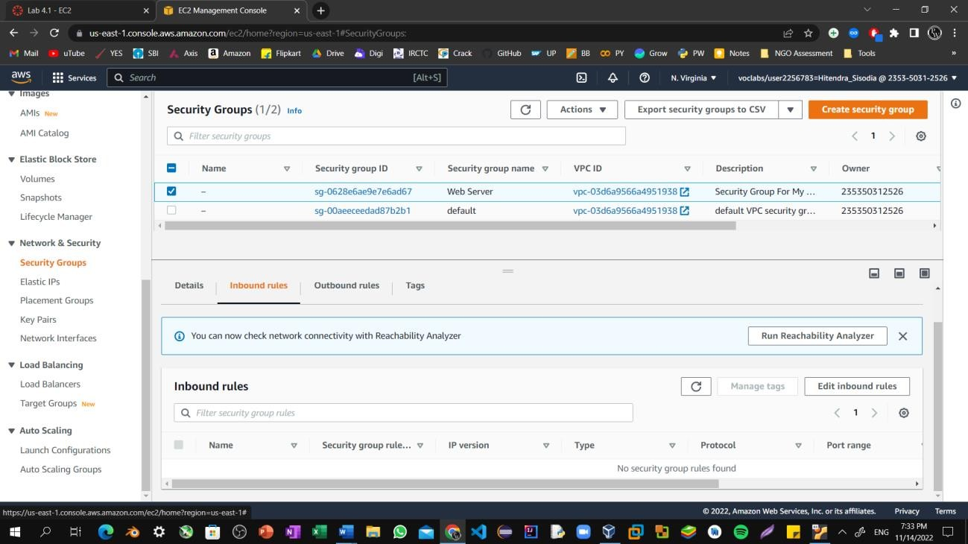Step21: Select the **Web Server** security group, which you created when launching your EC2 instance. In the lower pane, choose the **Inbound rules** tab.

Step22: Choose **Edit inbound rules**, and then choose **Add rule**.

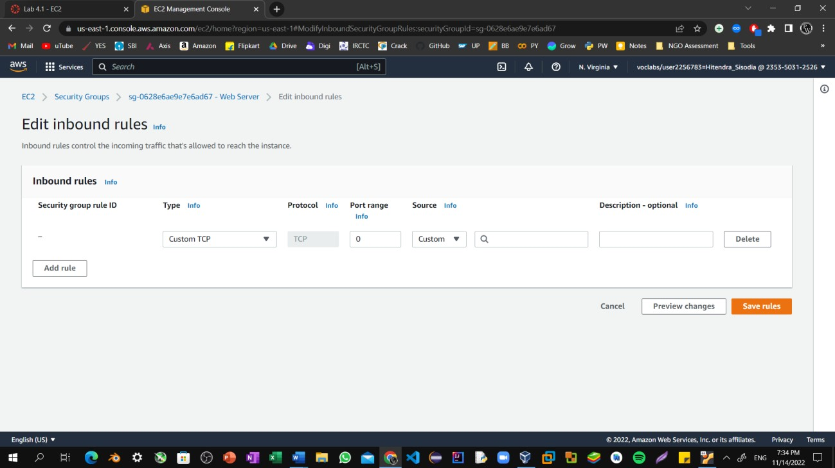

Step23: Configure the following:

**Type:** HTTP

**Source:** Anywhere-IPv4 Choose **Save rules**

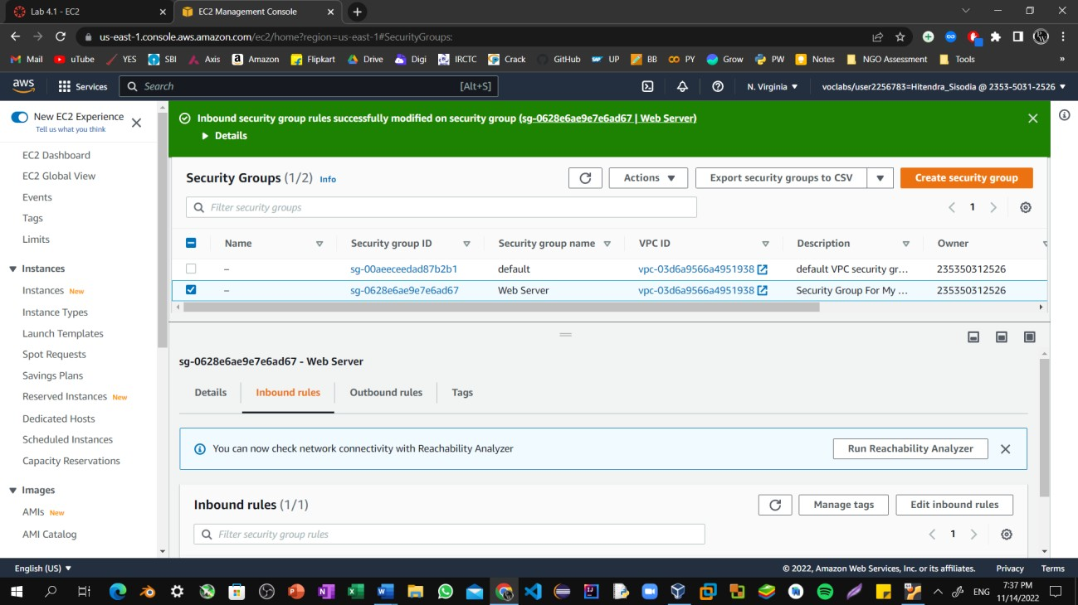

Step24: Return to the tab that you used to try to connect to the web server. The page should display the message *Hitendra Sisodia.*

